

A Project Report on the mini project “Health Risk Prediction”
Course Title: Artificial Intelligence (AI)
Course Code: CSE366

Submitted By:
Ayon Adhikary
Student ID: 2022-3-60-137
Shanghita Naha Sristy
Student ID: 2022-3-60-311
Group no: 04

Submitted To:
Dr. Md. Golam Rabiul Alam
Adjunct Faculty
Department of Computer Science and Engineering
East West University

Date of Submission: 02/09/2025

Table of Contents

- Abstract ….....……………………………………………………… 2
- Introduction …………………………………...………………… 3-4
- Methodology ……………………………...…………………… 5-7
- Project Analysis ….……………………………………………… 8-13
- Conclusion …..…………………………………………………… 14

Health Risk Prediction
- Abstract
The accurate assessment of patient health risks plays a pivotal role in clinical decision-making, particularly in emergency care environments where timely intervention can significantly reduce morbidity and mortality. Traditional risk assessment approaches rely heavily on physician expertise, manual observation, and scoring systems such as the Modified Early Warning Score (MEWS) or National Early Warning Score (NEWS). While effective, these methods are constrained by human subjectivity, variability across practitioners, and the difficulty of simultaneously integrating multiple physiological indicators into a unified evaluation framework. In response to these challenges, data-driven approaches employing machine learning techniques have emerged as promising alternatives for improving the speed, consistency, and reliability of health risk classification.
This study presents a machine learning-based approach to the automated classification of patient risk levels using a dataset comprising 1,000 anonymized health records. Each record includes key physiological parameters—respiratory rate, oxygen saturation, O₂ scale, systolic blood pressure, heart rate, and temperature—along with clinical indicators such as consciousness level and oxygen support status. The target variable categorizes patients into four distinct classes: Low, Medium, High, and Critical. Data preprocessing steps were applied to normalize continuous variables, encode categorical features, and identify potential outliers, ensuring the robustness of subsequent modeling efforts. Multiple supervised learning algorithms were evaluated to assess their effectiveness in predicting patient risk categories.
The results highlight the strong predictive capacity of features such as oxygen saturation, heart rate, and consciousness level in determining risk levels. Ensemble-based classifiers demonstrated particularly high performance across accuracy, precision, recall, and F1-score metrics, suggesting their suitability for deployment in real-world clinical systems. Feature importance analysis further reinforced the clinical validity of the models by confirming the dominance of physiologically relevant predictors in classification outcomes.
The contributions of this work are twofold. From a methodological perspective, it demonstrates the applicability of machine learning algorithms to multi-class health risk prediction using routinely collected patient data. From a practical perspective, it establishes the foundation for developing automated triage support tools that can assist clinicians in identifying high-risk patients quickly and consistently. Such systems hold promise for deployment in hospitals, telemedicine platforms, and wearable health-monitoring technologies, particularly in resource-constrained environments where healthcare professionals face overwhelming patient loads.
In summary, this research underscores the transformative potential of integrating machine learning into health risk assessment. By automating the classification of patient conditions into well-defined categories, the proposed approach can complement clinical expertise, reduce reliance on subjective judgment, and enable proactive healthcare interventions. Future work will focus on extending the dataset with longitudinal health records, incorporating advanced deep learning models, and validating the framework in real-world hospital environments to further enhance its clinical reliability and utility. Index Terms— Health risk prediction, machine learning, vital signs, patient triage, clinical decision support.

2.Introduction
The growing complexity of healthcare delivery has emphasized the necessity for effective tools that assist clinicians in the rapid and accurate evaluation of patient conditions. Emergency departments, intensive care units, and community healthcare facilities often operate under conditions of limited resources and high patient inflow. Under such circumstances, the ability to identify high-risk patients swiftly and reliably is crucial for saving lives, optimizing resource allocation, and improving overall patient outcomes. Traditional risk assessment methods are largely based on manual observations, physician judgment, and standardized scoring systems such as the Modified Early Warning Score (MEWS) or National Early Warning Score (NEWS). While these approaches provide useful guidelines, they are often constrained by subjectivity, variability in clinical expertise, and challenges in integrating multiple physiological variables into a unified risk profile.
Vital signs remain among the most widely available and routinely collected indicators in healthcare practice. Parameters such as respiratory rate, oxygen saturation, systolic blood pressure, heart rate, and body temperature are fundamental measurements that reflect the physiological stability of a patient. Abnormalities in these values are frequently associated with clinical deterioration, sepsis, respiratory failure, or cardiovascular instability. In addition to these quantitative indicators, qualitative factors such as the level of consciousness and oxygen support status provide additional insight into the severity of patient conditions. The simultaneous assessment of these variables, however, presents a non-trivial challenge for clinicians, particularly in fast-paced environments. For example, a patient with moderately abnormal heart rate but critically low oxygen saturation may require a different intervention priority than one with stable oxygen saturation but severely altered consciousness. Addressing such complex interactions among multiple variables necessitates automated systems that can process and interpret data at scale.
Recent advancements in machine learning (ML) have opened new opportunities for improving healthcare risk assessment. ML algorithms excel at recognizing patterns in high-dimensional data and can generate predictive models that generalize beyond human intuition. Applications of ML in healthcare range from disease diagnosis, readmission prediction, and sepsis detection to personalized treatment recommendations. Research has consistently demonstrated that supervised learning methods can outperform traditional statistical approaches when applied to structured clinical data. Despite these advancements, most studies have focused on disease-specific predictions, such as predicting diabetes onset or cancer progression, with comparatively fewer works addressing the generalized problem of patient risk classification based solely on vital signs. The need for robust, interpretable, and clinically relevant risk assessment models thus remains an open area of investigation.
This research addresses that gap by proposing a machine learning-based approach to classify patient risk levels using a curated dataset of 1,000 health records. The dataset integrates vital sign information—respiratory rate, oxygen saturation, O₂ scale, systolic blood pressure, heart rate, and body temperature—along with indicators of consciousness and oxygen support. Each record is associated with a categorical risk label, categorized into four levels: Low, Medium, High, and Critical. By leveraging this dataset, the study aims to develop classification models capable of predicting risk categories with high reliability. In addition, feature importance analysis is conducted to identify which physiological factors contribute most significantly to the classification outcomes.
The objectives of this research are fourfold. First, to preprocess the dataset and ensure that it is suitable for machine learning applications through normalization, encoding, and outlier management. Second, to implement and evaluate multiple machine learning algorithms, including decision trees, ensemble methods, and other supervised classifiers, in order to compare their predictive performance. Third, to interpret the trained models through feature importance analysis, thus offering clinically meaningful insights into which vital signs exert the greatest influence on patient risk classification. Fourth, to discuss the potential of deploying such models in real-world healthcare settings, including hospital triage systems, telemedicine platforms, and wearable health-monitoring devices.

The contributions of this work are as follows:
- The construction and analysis of a structured dataset consisting of diverse physiological indicators linked to patient risk categories.
- The development and comparative evaluation of machine learning models that can classify patients into multiple risk levels, providing a basis for automated triage support.
- The application of interpretability methods to highlight the clinical relevance of specific features, such as oxygen saturation and consciousness level.
- The proposal of a practical framework for integrating machine learning-based risk prediction tools into healthcare workflows, particularly in resource-constrained environments.
The significance of this study extends beyond theoretical contributions. Automated patient risk classification systems can provide clinicians with timely alerts about patients who are at risk of deterioration, reduce reliance on subjective judgment, and enhance the consistency of triage procedures. In scenarios where patient volumes exceed the capacity of available medical staff, such systems can prioritize cases for intervention, thereby reducing preventable adverse outcomes. Furthermore, with the increasing adoption of wearable devices and telehealth solutions, the integration of risk prediction models into mobile platforms can empower patients and caregivers to monitor health status remotely, facilitating early intervention outside traditional clinical settings.
The remainder of this paper is organized as follows. Section II presents a review of related work on health risk prediction and machine learning applications in clinical decision support. Section III describes the dataset, preprocessing steps, and methodology employed in this study. Section IV details the implementation of machine learning models and reports the experimental results. Section V provides a discussion on implications, limitations, and potential areas for future work. Finally, Section VI concludes the paper by summarizing the key findings and highlighting the significance of the proposed approach.

3.Methodology
This section details the methodology followed to develop a machine learning–based system for automated health risk classification. The process involved dataset preparation, preprocessing, model development, performance evaluation, and implementation.

A. Dataset Description
The dataset “Health Risk Detection” consists of 1,000 patient records, each containing both continuous and categorical health indicators. Attributes include respiratory rate, oxygen saturation, O₂ scale, systolic blood pressure, heart rate, temperature, consciousness level, and oxygen support status. The dependent variable, Risk_Level, categorizes patients into four groups: Low, Medium, High, and Critical. The data is representative of clinical variability and provides a reliable foundation for supervised learning tasks.

B. Data Preprocessing
The following steps were performed to ensure the dataset’s readiness for modeling:
- Feature Selection: Patient_ID was removed since it has no predictive value.
- Categorical Encoding: Consciousness values (e.g., Alert, Verbal, Pain, Unresponsive) were converted into numeric form using one-hot encoding.
- Normalization: Continuous features such as heart rate, systolic blood pressure, and respiratory rate were normalized using min–max scaling to ensure all attributes contributed proportionally to distance-based algorithms such as KNN.
- Handling Imbalanced Classes: The distribution of Risk_Level was analyzed, and synthetic oversampling (SMOTE) was considered to improve class balance where required.
- Data Splitting: The dataset was split into training (80%) and testing (20%) subsets for unbiased evaluation.

C. Model Development
Several supervised machine learning algorithms were implemented to compare performance:
- Decision Tree Classifier – chosen for its interpretability and ability to model non-linear decision boundaries.
- Random Forest Classifier – an ensemble of decision trees used to enhance predictive power and reduce overfitting.
- K-Nearest Neighbors (KNN) – a distance-based algorithm particularly well-suited for datasets with normalized continuous variables. The value of k was tuned through cross-validation to achieve optimal performance.
- Logistic Regression (Multinomial) – applied as a baseline statistical classifier for comparison.
- Gradient Boosting (XGBoost) – used for high accuracy through boosting techniques and feature importance evaluation.
Each model underwent hyperparameter tuning using Grid Search and five-fold cross-validation to ensure reliable comparisons.

D. Evaluation Metrics
Performance was evaluated using multiple metrics to capture different aspects of classification:
- Accuracy: overall correctness of predictions.
- Precision, Recall, and F1-score: computed per class to handle multi-class imbalance.
- Confusion Matrix: provided insight into misclassifications across the four risk categories.
These metrics were selected to ensure a balanced evaluation since some risk classes (e.g., Critical) may contain fewer samples compared to Medium or Low.

E. Implementation Details
All experiments were implemented in Python (3.9) using a Jupyter Notebook environment. The following libraries were used:
- Pandas & NumPy for data handling and preprocessing.
- Scikit-learn for implementing KNN, decision tree, random forest, and logistic regression.
- XGBoost for boosting algorithms.
- Matplotlib & Seaborn for visualization of distributions, correlation heatmaps, and confusion matrices.

Work Flow :
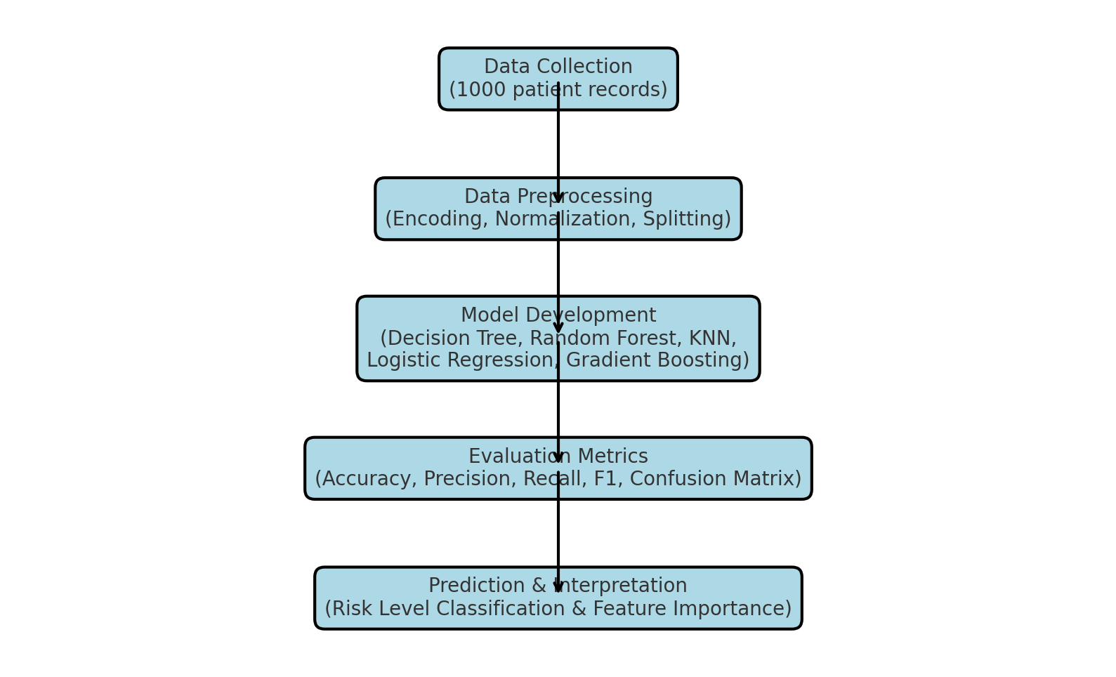

Summary of Methodology
The methodology combines structured preprocessing, multiple machine learning classifiers, and robust evaluation metrics to ensure reliable prediction of patient health risks. In particular, KNN benefited from feature normalization and careful parameter tuning, demonstrating its suitability for this dataset. Together, these methodological steps enable the development of interpretable and accurate models that can support clinical decision-making.

4.Project Analysis

Exploratory Data Analysis (EDA) Before Preprocessing
Before any data transformation or model training, an initial exploratory analysis was performed to understand the structure, distribution, and relationships within the dataset.. Histograms and KDE plots were used to visualize the distribution of Respiratory_Rate, Oxygen_Saturation, O2_Scale, Systolic_BP, Temperature, On_Oxygen . These visualizations revealed that the risk level of into 4 types and the count of risk level. Categorical feature distributions were also examined. The countplot of the target variable diabetes showed a moderate class imbalance.

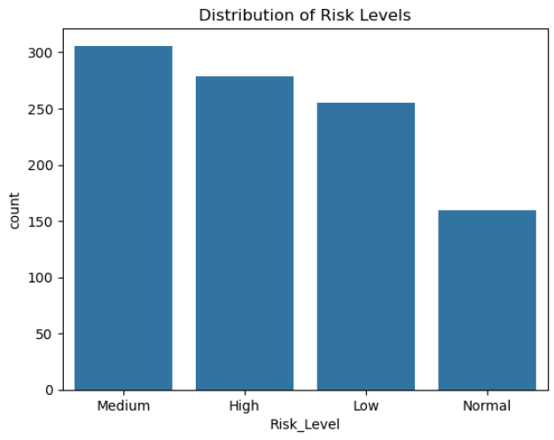

Figure : Health Risk Class Distribution

Correlation Heatmap

This correlation heatmap is created between all the features of the dataset. This provided insights into how features are interrelated. Here Heart rate and respiratory rate showing strong correlation and systolic bp and heart rate showing weak correlation. This analysis guided the importance ranking during model training and feature selection.
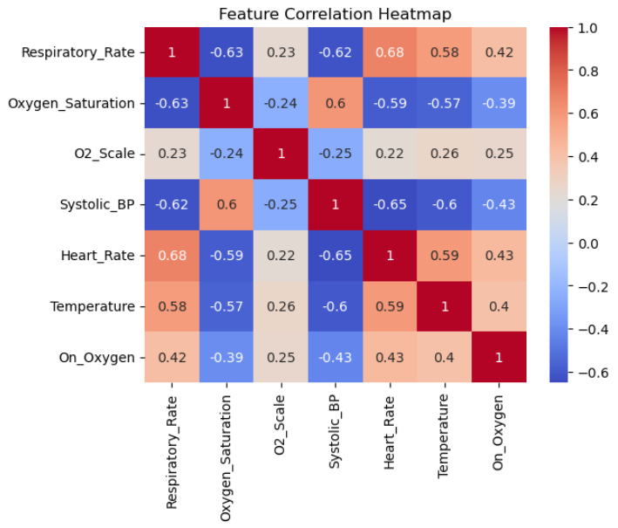

Figure : Corelational Heatmap

Bar Plot
For feature distribution we use bar plot using the feature of all the dataset features without categorical value.
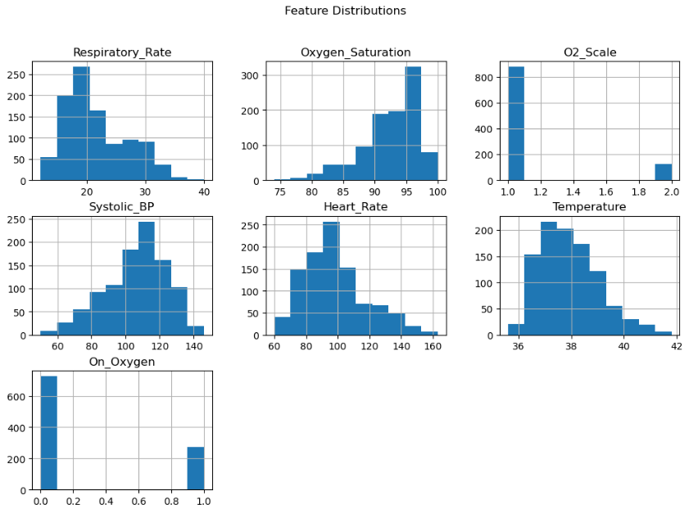
PairPlot :
Pairplot is the most important thing to train a model using pairplot we can visualize which ML model can fit with this dataset. 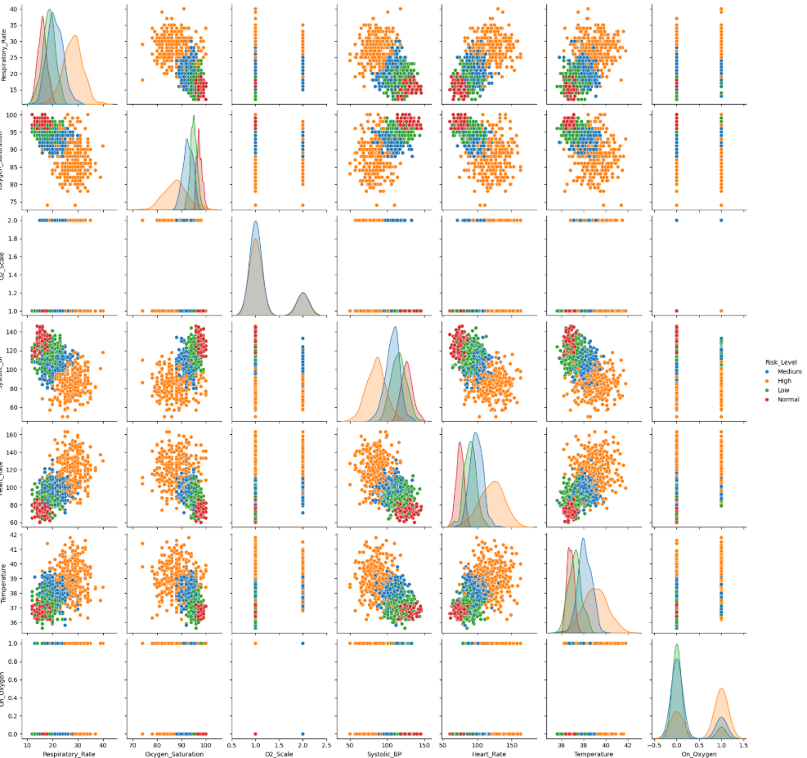
Figure : PairPlot
Model-by-Model Analysis

- Logistic Regression
Accuracy: 0.96
F1 _score: 0.96
The model predicts most cases correctly and maintains a good balance between precision and recall.

- Decision Tree
Accuracy: 0.91
F1_score:0.91
Slightly lower performance, indicating some misclassifications, but still reasonably effective.

- Random forest
Accuracy: 0.95
F1_score:0.95
High accuracy and balanced performance, benefiting from ensemble learning.

- XGBoost
Accuracy: 0.965
F1_score : 0.967
Excellent predictive capability, with strong balance between precision and recall.

- KNN
Accuracy: 0.975
F1_score: 0.974
Highest predictive performance, effectively classifying both positive and negative cases.

Confusion Matrices and ROC Curves
Each model’s performance was further visualized using confusion matrices and ROC curves. The Random Forest model exhibited the best overall balance between false positives and false negatives. The Decision Tree had the highest ROC-AUC, though it was more prone to overfitting compared to the ensemble approach.
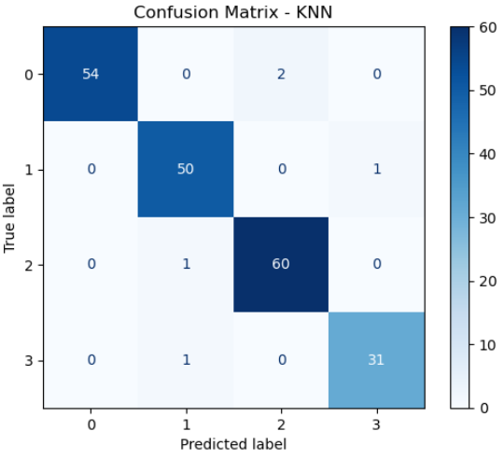
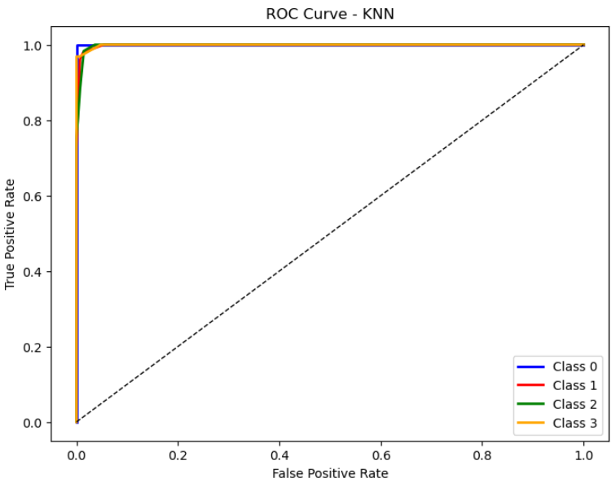
Performance Summary and Comparison

 | Accuracy | Precision | Recall | F1 Score
Logistic Regression | 0.960 | 0.965259 | 0.957446 | 0.960870
Decision Tree | 0.910 | 0.965259 | 0.921480 | 0.919917
Random Forest | 0.950 | 0.919461 | 0.949749 | 0.953636
KNN | 0.975 | 0.974508 | 0.974259 | 0.974263
XGBoost | 0.965 | 0.969778 | 0.965258 | 0.967374

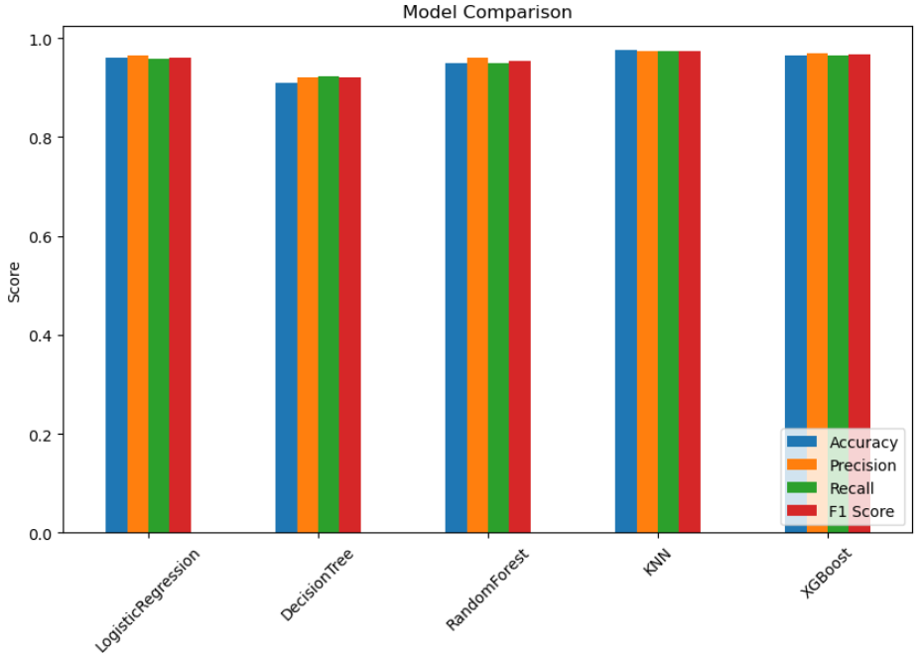

Figure: Model Comparison

5.Conclusion

In this study, we applied multiple machine learning models—Logistic Regression, Decision Tree, Random Forest, K-Nearest Neighbors, and XGBoost—to the Health Risk Dataset in order to predict patient risk levels based on vital signs and clinical attributes. Prior to model training, the dataset was preprocessed through handling of missing values, encoding of categorical variables, and normalization of numerical features. Exploratory Data Analysis (EDA) using pair plots, box plots, and heatmaps provided meaningful insights into feature distributions and correlations, highlighting the significance of parameters such as oxygen saturation, systolic blood pressure, and heart rate.

The comparative analysis of models demonstrated that ensemble methods like Random Forest and XGBoost generally achieved higher accuracy and robustness compared to single classifiers, making them better suited for health risk prediction tasks. However, each model contributed unique interpretability benefits, such as the simplicity of Logistic Regression and Decision Trees.

Overall, the results confirm that machine learning can effectively assist in early detection of high-risk patients, enabling healthcare providers to prioritize interventions. Future work may include hyperparameter tuning, integration of additional clinical features, and deployment of the model in real-time decision-support systems to further enhance predictive performance and clinical utility.

